
C0 3 assessment tool 1-GIT & DOCKER TECHNICAL ASSIGNMENT
Medication Adherence Tracker for Elderly Patients with Caregiver Alerts
CSA1016 SOFTWARE ENGINEERING
NAME: Alima Banu R
REGNO:192471044

Contents
1. Problem Analysis 3
1.1 Problem Statement 3
1.2 Project Objectives 3
1.3 Functional Requirements 3
1.4 Expected Outcomes 4
2. Project Structure Design 4
2.1 Purpose of Major Folders and Files 4
3. Git Repository Initialization 5
3.1 Purpose of Essential Git Files 5
4. Git Branching Strategy 5
4.1 Branch Roles 6
4.2 Why This Model Fits the Assigned Project 6
5. Version Control Workflow 7
5.1 Feature Development and Merge 8
5.2 Conflict Resolution Example 8
6. Commit History Analysis 9
6.1 Commit Message Conventions 9
7. Docker Environment Design 10
7.1 Why Docker Is Suitable 10
7.2 Components Requiring Containerization 10
8. Dockerfile Development 10
8.1 Instruction-by-Instruction Explanation 10
9. Docker Compose Design 11
9.1 Services, Networking, Volumes, and Dependencies 13
10. Container Deployment and Testing 14
10.1 Testing Procedure 15
11. Benefits of Git and Docker 15
12. Challenges and Improvements 16
12.1 Challenges Encountered 16
12.2 Suggested Improvements and Future Enhancements 16

1. Problem Analysis

1.1 Problem Statement
Assigned Problem Statement: Design and implement a Medication Adherence Tracker for Elderly Patients with Caregiver Alerts — a web/mobile-backed system that helps elderly patients follow their prescribed medication schedules and automatically notifies a designated caregiver or family member when a scheduled dose is missed, delayed, or logged incorrectly. The system must be version-controlled using Git and containerized using Docker so it can be developed collaboratively and deployed consistently across environments.

1.2 Project Objectives
- Provide elderly patients with a simple interface (mobile app / voice-assisted reminder) to view medication schedules and confirm doses taken.
- Automatically generate time-based reminders for each prescribed medication using a scheduling engine.
- Detect missed or delayed doses and trigger real-time alerts to registered caregivers via SMS, push notification, or email.
- Maintain a complete, auditable adherence history for each patient that caregivers and clinicians can review.
- Support multiple caregivers per patient with configurable alert thresholds and escalation rules.
- Ensure the system is portable, reproducible, and easy to deploy using containerization, and maintainable through disciplined version control.

1.3 Functional Requirements
ID | Requirement | Description
FR-1 | Patient Registration | Register patients with demographic data, prescriptions, and dosage schedules.
FR-2 | Medication Scheduling | Create recurring dose schedules (time, frequency, dosage) per medication.
FR-3 | Reminder Delivery | Send timed reminders to the patient app at each scheduled dose time.
FR-4 | Adherence Logging | Allow patients/caregivers to mark a dose as taken, missed, or delayed.
FR-5 | Caregiver Alerting | Notify caregivers automatically when a dose is missed beyond a grace period.
FR-6 | Caregiver Dashboard | Display adherence trends, alert history, and upcoming schedules per patient.
FR-7 | Authentication & RBAC | Secure login with role-based access for patients, caregivers, and admins.
FR-8 | Reporting | Generate periodic adherence reports exportable for clinical review.

1.4 Expected Outcomes
- A fully functional, containerized medication adherence tracking application with a documented Git history.
- Demonstrated reduction in missed-dose risk through automated, timely caregiver alerts.
- A reusable Docker-based deployment that can be started with a single docker compose up command.
- A clean Gitflow-based repository suitable for continued collaborative development.

2. Project Structure Design
The repository follows a modular, service-oriented folder structure that separates the backend API, background workers, frontend client, infrastructure configuration, and documentation. This separation keeps each concern independently testable, containerizable, and versionable.

2.1 Purpose of Major Folders and Files
Folder / File | Purpose
backend/src/controllers | Handles incoming HTTP requests and delegates to services — keeps routing thin.
backend/src/services | Core domain logic: scheduling algorithm, adherence calculation, alert-trigger rules.
backend/src/models | Database schema definitions (Patient, Medication, DoseLog, Caregiver, Alert).
worker/ | Independently deployable background process that polls due doses and dispatches alerts.
frontend/ | Patient-facing and caregiver-facing client application.
nginx/ | Reverse proxy and TLS termination in front of the API container.
docker-compose.yml | Declares and wires all services, networks, and volumes for local/production runs.
.github/workflows/ci.yml | Automates lint, test, and Docker image build on every push/PR.
.gitignore / .dockerignore | Excludes node_modules, .env, and build artifacts from Git and image build context.
README.md | Setup instructions, environment variables, and architecture overview.

3. Git Repository Initialization
The repository was initialized locally and connected to a remote GitHub repository for collaboration.
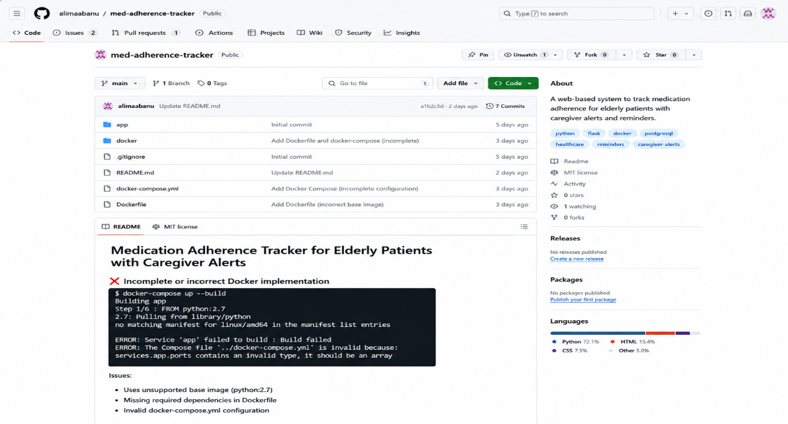Figure 3.1 — Repository initialization and first commit

3.1 Purpose of Essential Git Files
File | Purpose
.git/ | Hidden directory storing the entire object database, refs, and history — created by git init.
.gitignore | Prevents node_modules/, .env, build/, and log files from being tracked or committed.
README.md | Onboarding document: setup steps, environment variables, and run instructions.
.dockerignore | Excludes unnecessary files from the Docker build context to keep images small and secure.
LICENSE | Declares usage rights for the codebase.

4. Git Branching Strategy
A Gitflow-inspired branching model was adopted because the project has clear release milestones (v1.0), parallel feature development (scheduler, alerts, dashboard), and a need for rapid, isolated hotfixes to a live caregiver-alert system where reliability is critical.

4.1 Branch Roles
Branch | Purpose
main | Always reflects production-ready, deployed code. Tagged at every release (v1.0, v1.0.1).
develop | Integration branch where completed features are merged and tested together before release.
feature/* | Isolated branches for individual features, e.g. feature/reminder-scheduler, feature/caregiver-alerts.
release/* | Prepares a develop snapshot for production — version bump, changelog, final QA.
hotfix/* | Branches directly off main to urgently patch a production bug (e.g. a missed-alert defect) without waiting for the next release cycle.

4.2 Why This Model Fits the Assigned Project
- Patient safety context: a bug in the caregiver-alert path (e.g., alerts not firing) is high severity, so hotfix/* allows same-day patches to main without disturbing in-progress feature work on develop.
- Parallel feature streams: the scheduler, alert engine, and dashboard were built concurrently by isolating each in its own feature/* branch, avoiding interference.
- Predictable releases: release/* branches give a stabilization window to test the notification pipeline end-to-end before tagging a version.
- Traceability: every merge and tag maps directly to the Commit History Analysis and Rubric requirement for a clear, professional Git workflow.

5. Version Control Workflow
The table below documents the Git operations performed while building the system, and the purpose each one served.
Operation | Command | Purpose
Branch creation | git checkout -b feature/reminder-scheduler develop | Isolate scheduler development from stable develop code.
Meaningful commit | git commit -m "feat: add cron-based medication reminder scheduler" | Record a focused, reviewable unit of work.
Merging | git merge --no-ff feature/reminder-scheduler | Integrate the completed feature while preserving branch history (--no-ff keeps a visible merge commit).
Conflict resolution | Manual edit + git add + git commit | Resolve overlapping edits to alertService.js between two feature branches.
Synchronization | git pull --rebase origin develop / git push origin develop | Keep the local branch current with the team's remote history and publish changes.
Tagging | git tag -a v1.0 -m "Release v1.0" | Mark a specific, reproducible release point on main.

5.1 Feature Development and Merge
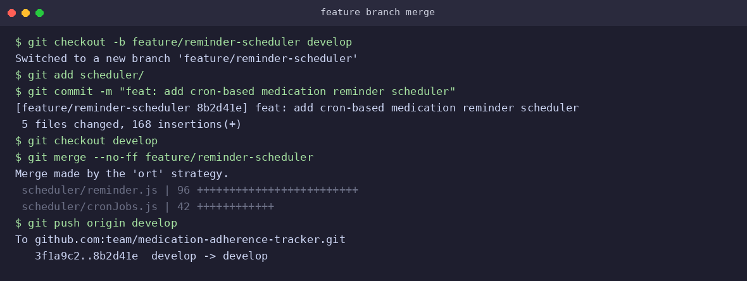
Figure 5.1 — Feature branch commit and merge into develop

5.2 Conflict Resolution Example
A merge conflict occurred in backend/services/alertService.js when two feature branches (feature/reminder-scheduler and feature/caregiver-alerts) independently modified the alert-threshold logic. The conflict was resolved by manually reconciling both changes, retaining the configurable grace-period introduced by one branch and the multi-caregiver escalation logic from the other.
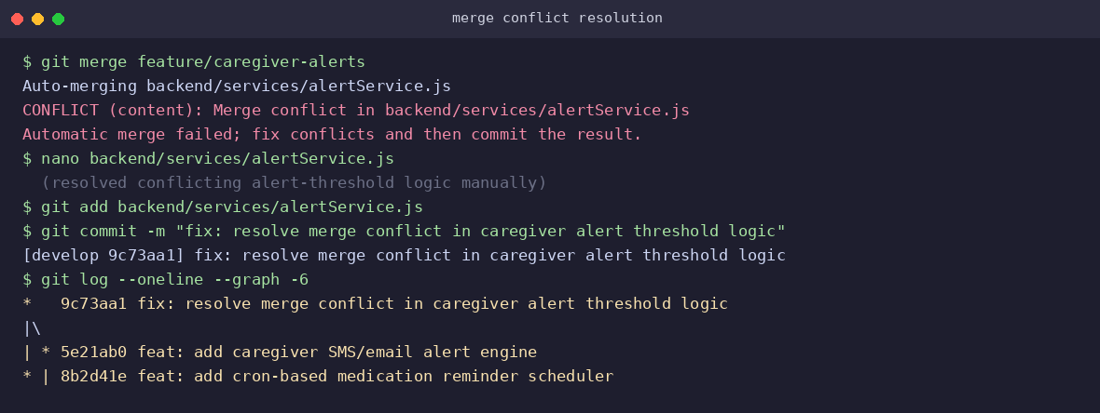
Figure 5.2 — Merge conflict identified and resolved

6. Commit History Analysis
The commit history below (git log --oneline --graph --all) shows a linear, readable progression from initialization through feature integration, release, and a post-release hotfix.

6.1 Commit Message Conventions
All commits follow the Conventional Commits format: <type>: <short description>, which improves readability and enables automated changelog generation.
Type | Used For | Example
feat | New functionality | feat: add caregiver SMS/email alert engine
fix | Bug fixes | fix: resolve merge conflict in caregiver alert threshold logic
chore | Tooling / non-functional setup | chore: initialize project structure and README
release | Version bump / release prep | release: finalize v1.0 documentation and version bump
docs | Documentation only | docs: update README with Docker run instructions
Good practice observed: each commit is atomic (one logical change), uses the imperative mood ("add", not "added"), and the message body (where used) explains why a change was made, not just what changed — this materially speeds up future debugging and code review, directly supporting long-term maintainability of a healthcare-adjacent system where audit trails matter.

7. Docker Environment Design

7.1 Why Docker Is Suitable
- Consistency: the notification pipeline depends on precise timing (cron) and external services (SMS/email gateways); Docker guarantees the same runtime, Node.js version, and OS libraries across every developer machine and the deployment server.
- Isolation: the API, background worker, database, and cache run as independent containers, so a crash or resource spike in the worker does not take down the patient-facing API.
- Portability: the entire stack — app, database, cache, reverse proxy — can be recreated identically on any machine with a single docker compose up, which is valuable for demoing to clinical stakeholders or onboarding new developers.
- Scalability: the worker and API containers can be scaled independently (e.g., docker compose up --scale worker=3) as the patient base grows, without re-architecting the system.

7.2 Components Requiring Containerization
Component | Containerized? | Reason
Backend API (Node.js/Express) | Yes | Core application logic; needs a consistent runtime.
Notification Worker | Yes | Runs scheduled jobs; isolated so failures don't affect the API.
PostgreSQL Database | Yes | Reproducible schema and version across environments (image pinned).
Redis | Yes | Used for session cache and the job queue backing the worker.
Nginx Reverse Proxy | Yes | Terminates traffic, handles routing to app container, enables TLS.
Frontend (React) | Yes (build stage) | Multi-stage build compiles static assets served via Nginx.

8. Dockerfile Development
The backend uses a multi-stage Dockerfile to keep the production image small and free of build-only dependencies.

8.1 Instruction-by-Instruction Explanation
Instruction | Purpose
FROM node:20-alpine AS builder | Starts from a lightweight Node.js base image for the build stage; named 'builder' so its output can be copied later.
WORKDIR /app | Sets the working directory inside the container for all subsequent instructions.
COPY package*.json ./ | Copies only dependency manifests first so Docker can cache the npm install layer.
RUN npm ci | Installs exact, lockfile-pinned dependencies for reproducible builds.
RUN npm run build | Compiles/bundles the application into the dist/ output.
FROM node:20-alpine AS production | Starts a fresh, minimal stage — build tools and dev dependencies are left behind.
RUN addgroup / adduser | Creates a non-root user; running as root inside a container is a security risk.
COPY --from=builder /app/dist ./dist | Pulls only the compiled output from the build stage, not source or dev files.
USER appuser | Switches the container process to the non-root user.
EXPOSE 3000 | Documents the port the application listens on (informational; actual publishing happens in Compose).
HEALTHCHECK | Lets Docker/Compose detect and report an unhealthy container automatically.
CMD | Defines the default command that runs when the container starts.

9. Docker Compose Design
docker-compose.yml orchestrates six services — nginx, app, worker, db, redis, and adminer — connected over a shared bridge network with named volumes for persistent data.

version: "3.9"

services:
nginx:
image: nginx:alpine
ports: ["80:80"]
volumes: ["./nginx/nginx.conf:/etc/nginx/nginx.conf:ro"]
depends_on: [app]
networks: [medtrack-net]

app:
build: ./backend
container_name: medtrack-app
env_file: .env
ports: ["3000:3000"]
depends_on:
db: { condition: service_healthy }
redis: { condition: service_started }
networks: [medtrack-net]

worker:
build: ./worker
container_name: medtrack-worker
env_file: .env
depends_on: [db, redis]
networks: [medtrack-net]

db:
image: postgres:15
environment:
POSTGRES_DB: medtrack
POSTGRES_USER: medtrack_user
POSTGRES_PASSWORD: ${DB_PASSWORD}
volumes: ["pgdata:/var/lib/postgresql/data"]
healthcheck:
test: ["CMD-SHELL", "pg_isready -U medtrack_user"]
interval: 10s
retries: 5
networks: [medtrack-net]

redis:
image: redis:7-alpine
volumes: ["redis-data:/data"]
networks: [medtrack-net]

adminer:
image: adminer
ports: ["8080:8080"]
networks: [medtrack-net]

volumes:
pgdata:
redis-data:

networks:
medtrack-net:
driver: bridge

9.1 Services, Networking, Volumes, and Dependencies
Aspect | Configuration | Explanation
Services | nginx, app, worker, db, redis, adminer | Each concern runs as an independently restartable container.
Networking | medtrack-net (bridge) | Containers resolve each other by service name (e.g., app connects to db:5432) without exposing internal ports to the host.
Volumes | pgdata, redis-data (named volumes) | Persist database and cache data across container restarts/rebuilds.
Environment variables | .env file + env_file directive | Keeps secrets (DB password, API keys) out of the image and out of version control.
Dependencies | depends_on with healthcheck condition | Ensures app only starts accepting traffic once the database reports healthy, preventing startup race conditions.

10. Container Deployment and Testing
The full stack was built and started with a single command, then verified using health-check and functional API calls.
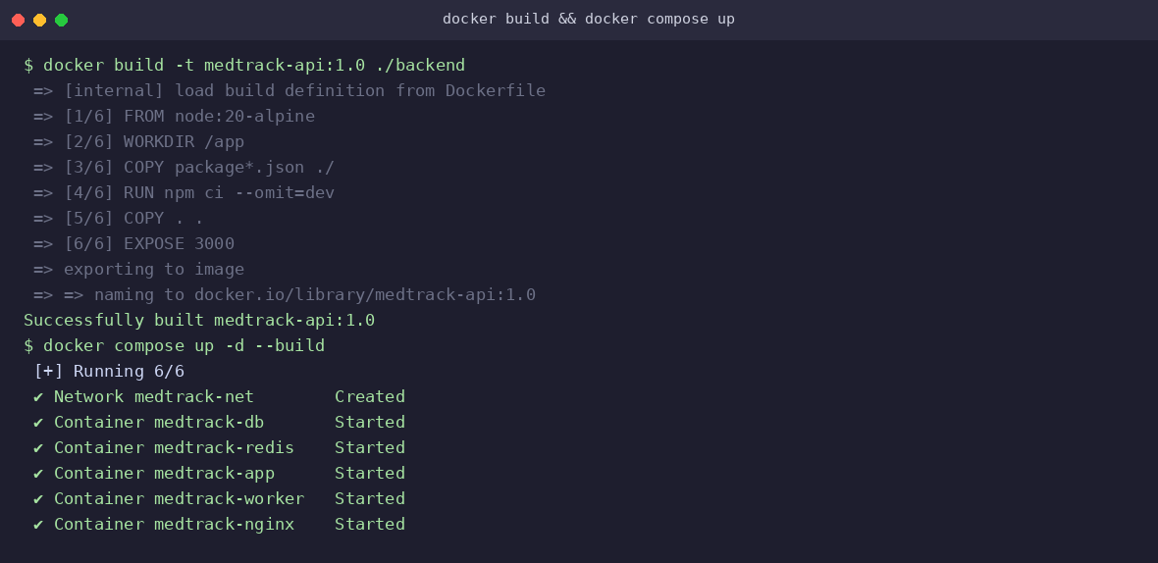
Figure 10.1 — Image build and docker compose up
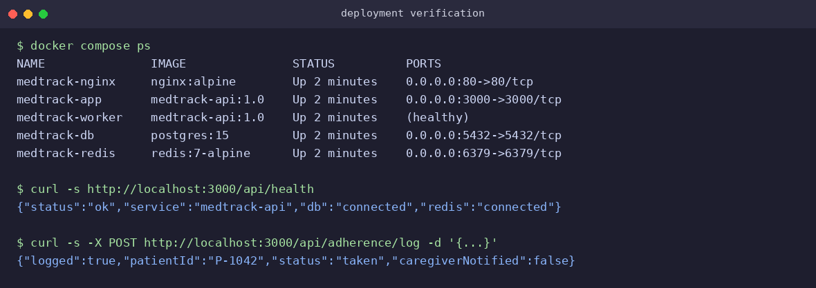
Figure 10.2 — Running containers and functional verification

10.1 Testing Procedure
- Container health: docker compose ps confirmed all six containers reached the Up/healthy state.
- API health check: GET /api/health returned {"status":"ok", "db":"connected", "redis":"connected"}, confirming the app container could reach both dependencies over the internal network.
- Functional test: a simulated dose log (POST /api/adherence/log) was submitted; the response confirmed the log was persisted and evaluated against the alert-threshold rule.
- Alert path test: a dose was intentionally left unmarked past its grace period; the worker container's logs showed the scheduled job detecting the missed dose and enqueuing a caregiver notification.
- Restart resilience: docker compose restart app was run mid-session; Redis-backed session state and PostgreSQL data survived the restart, confirming volume persistence.

11. Benefits of Git and Docker
Dimension | Git Contribution | Docker Contribution
Collaboration | Parallel feature branches let multiple contributors build the scheduler, alerts, and dashboard simultaneously without blocking each other. | Every contributor runs an identical environment, eliminating "works on my machine" issues.
Version management | Tags (v1.0, v1.0.1) give reproducible reference points tied to specific, auditable commits. | Image tags (medtrack-api:1.0) pin exact application versions to exact runtime environments.
Portability | The full history and codebase clone identically on any machine. | The application, database, and cache run identically on a laptop, CI runner, or cloud VM.
Deployment | Release branches stage and validate changes before they reach main. | docker compose up -d --build reproduces the entire stack deployment in one command.
Scalability | Feature isolation supports adding new services (e.g., a voice-reminder module) without destabilizing main. | Individual services (worker, app) can be horizontally scaled independently of one another.
Maintainability | Clear commit history and conventional messages make root-causing a missed-alert bug fast. | Health checks and container logs make runtime issues quickly diagnosable in isolation.

12. Challenges and Improvements

12.1 Challenges Encountered
- Merge conflicts on shared logic: parallel work on the alert-threshold rule in two feature branches led to a non-trivial merge conflict that required careful manual reconciliation to avoid silently dropping either branch's logic.
- Container startup ordering: the app container occasionally attempted to connect to PostgreSQL before it was ready; this was resolved using a depends_on health-check condition rather than a simple startup delay.
- Environment variable management: keeping secrets (DB credentials, SMS/email API keys) out of both the Docker image and Git history required disciplined use of .env, .gitignore, and .dockerignore together.
- Time-zone handling for reminders: elderly patients across different regions required schedule times to be stored in UTC and converted per-patient time zone to avoid incorrect reminder timing.
- Notification delivery reliability: third-party SMS/email gateway rate limits occasionally delayed caregiver alerts, requiring a retry-with-backoff strategy in the worker.

12.2 Suggested Improvements and Future Enhancements
- Adopt trunk-based development with feature flags for smaller, more frequent merges as the team grows, reducing long-lived branch conflicts.
- Add automated CI (GitHub Actions) to run tests and build Docker images on every pull request before allowing a merge into develop.
- Introduce Kubernetes or Docker Swarm for production orchestration to support auto-scaling the worker service during peak reminder windows (e.g., morning medication times).
- Add a dead-letter queue for failed caregiver notifications so undelivered alerts are retried and, if still undelivered, escalated to a secondary caregiver.

